**2023/24 Tenant Satisfaction Measure (TSM) Results are here!**

Last year, the Regulator of Social Housing introduced a new requirement for all social housing landlords to annually report on a set of measures that tells you how we are doing at providing quality homes and services.

The measures aim to improve standards for people living in social rented housing by:

* Showing you how well we are doing on important things like delivering repairs, dealing with complaints and treating you with respect
* Allowing you to hold us to account when we are not performing as we should
* Giving the Regulator an insight into which landlords may need to improve things for their customers

TSMs will show how well we:

* Keep your homes in a good state of repair
* Ensure your homes are safe
* Give you opportunities to have your say, and act on your views
* Handle complaints.

**There are 22 TSMs**, including:

* **12 Tenant Perception Measures** – these are measured via an annual survey, which took place between January and March 2024.
* **10 General Management Measures** – these are measured through information we hold within our systems and by repairs contractors

**Tenant Perception Measures TSM Results**

Thank you to all those customers who took part in completing the satisfaction survey. It has helped us to understand what we are doing well and also consider the areas we can improve on. Your feedback is really important to us.

Here’s a look at what you said about us:

|  |  |  |  |
| --- | --- | --- | --- |
|  | 78.2% | satisfied with the overall service provided by Westmorland and Furness Council’s Housing Service | |
| **84%** satisfied with the overall repairs service | | | **78.9%** feel we treat them fairly and with respect |
| **80.8%** satisfied with the time taken to complete their most recent repair | | | **49.3%** satisfied with our approach to complaints handling |
| **71.8%** satisfied that their homes are well maintained | | | **67.1%** satisfied communal areas are clean and well maintained |
| **77.4%** satisfied that their home is safe | | | **54.7%** satisfied we make a positive contribution to their neighbourhood |
| **58.2%** satisfied we listen and act upon their views | | | **56.5%** satisfied with our approach to handling anti-social behaviour |
| **71.5%** satisfied we keep them informed about things that matter to them | | |

Having reviewed the results of the survey, we have looked at those tenant perception measures that fell below 70% to look further at the responses and also provide some further information as can be seen summarised below:

|  |
| --- |
| **TP06- satisfaction with how we listen and act upon your views (58.2%)** |
| Only 12.6% responded to say they were dissatisfied, with the remaining 35.1% providing a neutral answer or responding they didn’t know or the question was n/a. This survey marks the start of an annual opportunity to share your views and provide us with insight into how we can do better. The safe and strong team are regularly out and about in communities carrying out visits and ‘street safe’ events so look out for these for your chance to have your say. |
| **TP09- satisfaction with our handling of complaints (49.3%)** |
| 39.5% of you said you were dissatisfied with the way we handle complaints. However the management TSM’s suggest that we receive a significantly lower number of stage 1 and 2 complaints that local providers and also compared to national averages. We only had 1 complaint escalated to stage 2 in 2023/24, which suggests we resolved those complaints received successfully at stage 1. |

|  |
| --- |
| **TP10- satisfaction with communal areas (67.1%)** |
| 23.4% of you were dissatisfied with the how we maintain communal areas and ensure they are clean. The Council have an arrangement with a third party contractor to carry out cleaning on all communal blocks. The supervisor also post inspects the blocks to ensure the standards expected are met. We will continue to monitor this. Our mobile caretaking unit (MCU) are also on hand to help keep communal areas clear and maintained but have had some resource issues in 2023/24, which we hope to have resolved soon. |
| **TP11- satisfaction that we make a positive contribution to neighbourhoods (54.7%)** |
| Only 13.5% of you said were dissatisfied with this measure with 40.4% providing a neutral answer or responding they didn’t know or the question was n/a. As a service, we do carry out lots of positive work in communities, which you can see more information on in our newsletter. We think we need to get better at communicating this with our customers, which we will do moving forward. |
| **TP12- satisfaction with the handling of anti-social behaviour (56.5%)** |
| Only 13.4% of you said you were dissatisfied with the way we handle anti-social behaviour with 43.3% providing a neutral answer or responding they didn’t know or the question was n/a. Our performance is in line with national averages but lower than other local social housing providers. However our general management TSM’ do show the number of anti-social behaviour cases per 1000 homes is considerably higher in comparison to those providers, which means we may take longer to resolve cases. |

You can find an action plan on pages 7 and 8 that shows how we plan to address the issues raised during the process of gathering the TSMs.

**General Management TSMs**

|  |  |  |
| --- | --- | --- |
|  | **Management Information 2023/2024** | **W&FC** |
| **BS01** | Proportion of homes for which all required gas safety checks have been carried out | **99.9%** |
| **BS02** | Proportion of homes for which all required fire risk assessments have been carried out. | **100%** |
| **BS03** | Proportion of homes for which all required asbestos management surveys or re-inspections have been carried out. | **100%** |
| **BS04** | Proportion of homes for which all required Legionella risk assessments have been carried out. | **100%** |
| **BS05** | Proportion of homes for which all required communal passenger lift safety checks have been carried out. | **N/A** |
| **RP01** | Proportion of homes that do not meet Decent Homes Standard | **0%** |
| **RP02(1)** | Proportion of non-emergency responsive repairs completed within the landlord’s target timescales. | **69.8%** |
| **RP02(2)** | Proportion of emergency responsive repairs completed within the landlord’s target timescales. | **78.6%** |
| **NM01** | Number of anti-social behaviour cases opened per 1,000 homes | **271.7** |
| **NM02** | Number of anti-social behaviour cases that involve hate crime incidents opened per 1,000 homes | **10.1** |
| **CH01(1)** | Number of stage 1 complaints received per 1,000 homes | **8.5** |
| **CH01(2)** | Number of stage 2 complaints received per 1,000 homes | **0.3** |
| **CH02(1)** | Proportion of stage 1 complaints responded to within the Housing Ombudsman’s Complaint Handling Code timescales | **90.9&** |
| **CH02(2)** | Proportion of stage 2 complaints responded to within the Housing Ombudsman’s Complaint Handling Code timescales | **100%** |

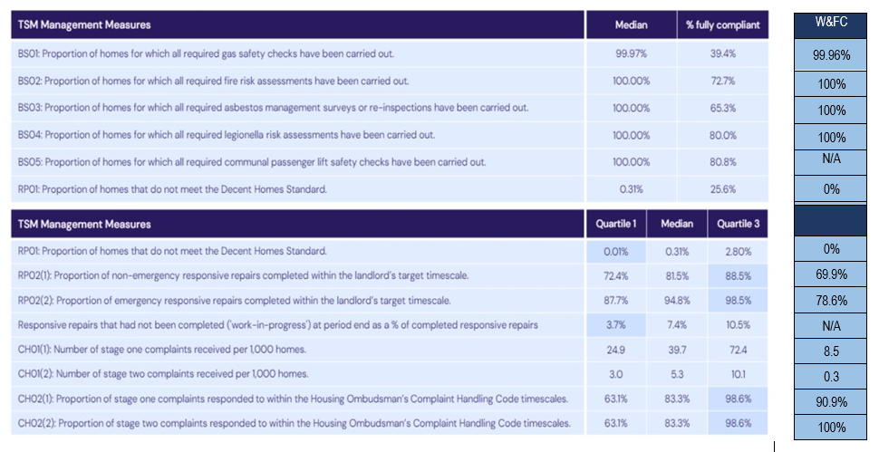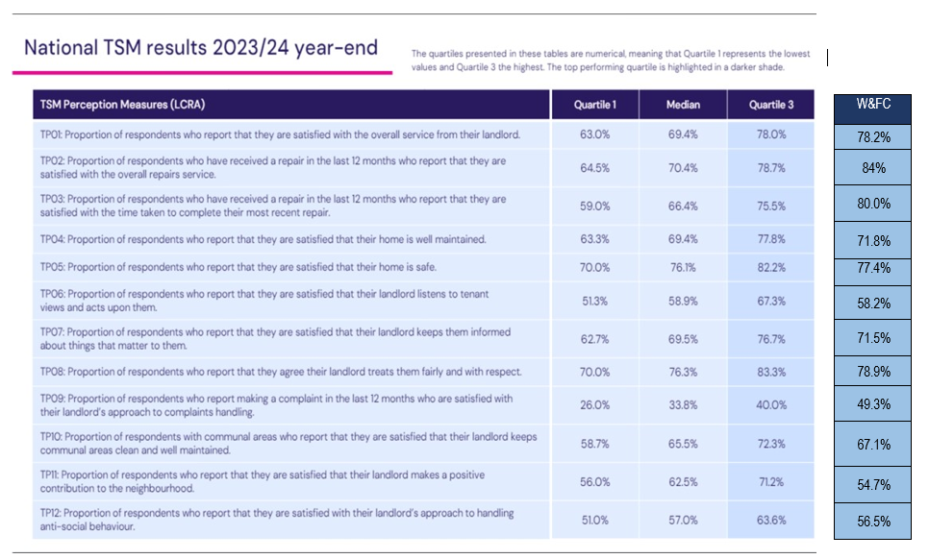**How do we compare with the national TSM results 2023/24* (as published by Housemark 2024)? Take a look below:**

*The quartiles presented in these tables are numerical meaning that Quartile 1 represents the lowest values and Quartile 3 the highest. The darker shaded cells highlight the top performing values.

Of the 22 measures, Westmorland & Furness Council are in line with the national TSM values for 12 of the 22 measures. We exceed the upper quartile TSM values for seven of the measures but fall slightly below the national TSM value for two of the measures around positive contributions to neighbourhoods and repairs completed within target timescales*.

You can see what we plan to do around these measures in the action plan shown below:

*The performance for gas repairs is high at 96.7% (emergency) and 98.9% (non-emergency).

| **Tenant Satisfaction Measures Action Plan 2024/25** | | | |
| --- | --- | --- | --- |
| **TSM** | **Description** | **Action** | **Completed by** |
| **General** | **Increase the number of tenants who participated in the annual survey to give a more effective measure of satisfaction and our performance as a landlord** | * Include the survey within the winter edition of the Housing newsletter for people to remove and complete (alongside the other collection methods) and provide pre-paid envelope * Carry out two phases, the first as outlined above and a second phase to re-contact those who have not submitted the survey * Use ‘street safe’ events as a way to collect responses * Have a ‘have your say’ month where any Officers who come into contact with tenants are encouraged to support them to complete the survey. Ensure this can be done at Council offices as well. | Dec 2024  Feb 2025  Ongoing  Feb 2025 |
| **General** | **Aim to contact a sample of dissatisfied responders for measure less than 70% to gain further insight** | * Identify a sample through the survey analysis tool and endeavour to contact an agreed % of those dissatisfied with measures that fall below 70% to gain further insight and view of how we could improve | Feb 2025 |
| **TP06** | **Satisfaction with how we listen and act upon your views** | * Provide more information on how we have acted on customer feedback such as ‘You said, we did’ * Ensure all areas have a ‘street safe’ event planned to give opportunity for tenants to raise issues * Follow the action plan set out here to show we have listened * Provide a summary in the newsletter of key issues raised and how we have addressed these | Ongoing  Aug 2024  March 2025  Dec 2024 |
| **TP09** | **Satisfaction with our handling of complaints** | * Ensure tenants are aware of the new Complaint Handling Code and know what to expect and when * Provide training to those handling complaints to ensure they know their responsibilities, timescales and actions that should be taken to resolve complaints | Aug 2024  Aug 2024 |
| **TP10** | **Satisfaction with communal areas** | * Continue to spot check communal areas to ensure the expected standards are being met by the Contractor delivering this service * Increase the resource available from Mobile Caretaking Unit (MCU) to ensure communal areas are kept clear from obstructions * Continue to address fly tipping via the Safe & Strong Communities Team | Ongoing  Ongoing  Ongoing |
| **TP11** | **Satisfaction that we make a positive contribution to neighbourhoods** | * Improve the way we publicise information about the work we are doing in communities * Share updates on social value achievements through the procurement framework annually * Review incentive schemes to encourage tenants to make positive contributions to neighbourhoods * Increase the resource available from MCU to ensure communal areas are kept clear from obstructions | Immediate  March 2025  Sept 2024  Ongoing |
| **TP12** | **Satisfaction with the handling of anti-social behaviour** | * Enhance the system we have in place for logging and monitoring ASB cases to provide more effective oversight on the length of time taken to resolve cases and number of people affected * Ensure all areas have a ‘street safe’ event planned to give opportunity for tenants to raise ASB issues * Consider increasing the resource available to manage ASB cases as budgets allow | Sept 2024  August 2024  March 2025 |
| **RP02** | **Responsive repairs completed within the landlord’s target timescales** | * Ensure regular meetings with contractors responsible for delivering the responsive repairs service take place to hold contractors to account on their performance * Identify issues with certain trades that may need to be addressed by allocation of work to sub-contractors (as per procurement rules and the underlying contracts)   This action relates to non-gas repairs as the gas repair performance is high. | Monthly meetings in place. Quarterly reporting from July 24  Immediate |