Cumbria Food
Liaison Group

Directory of Food Hygiene Trainers


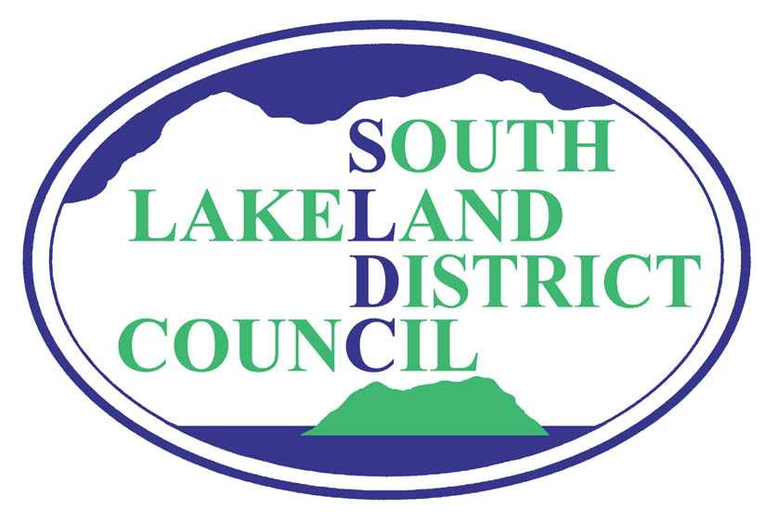
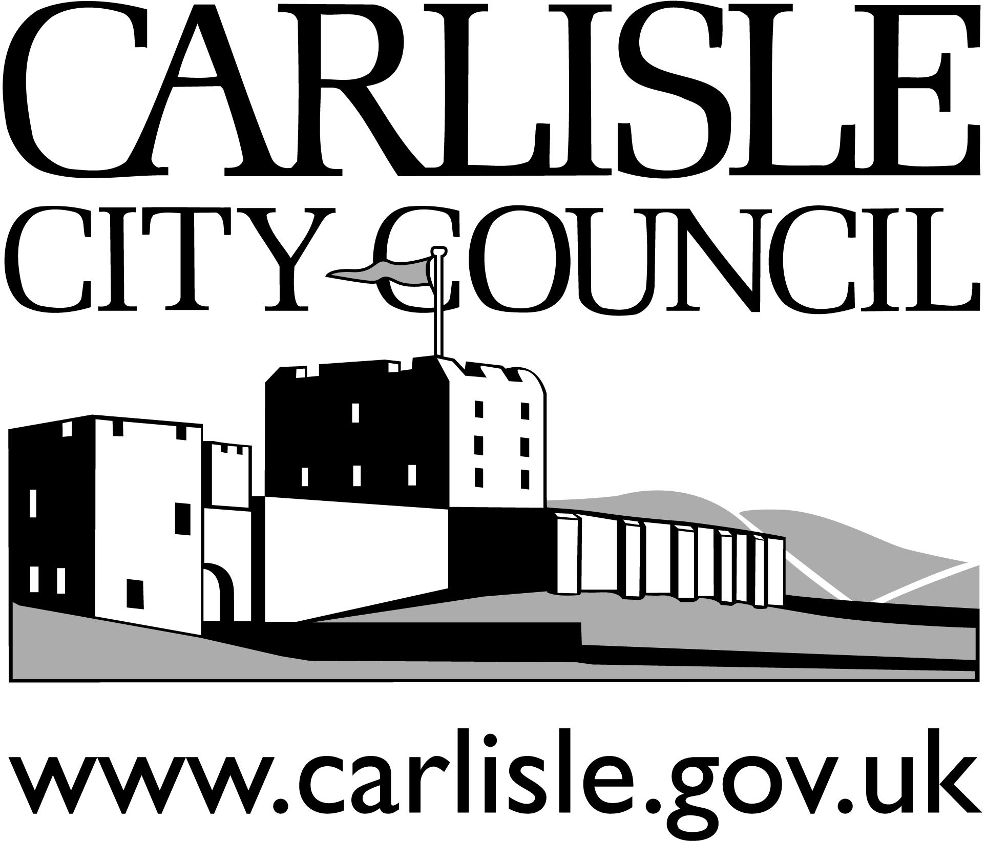

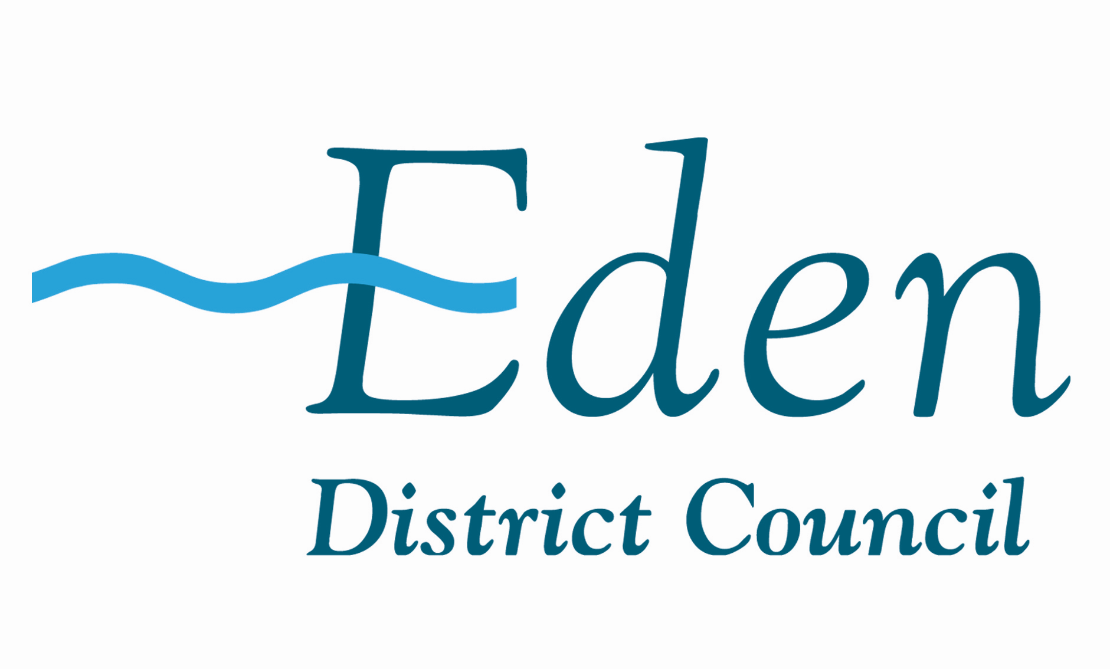
(Updated March 2014)

Food Hygiene Training
A number of awarding bodies provide qualifications in food safety which are delivered by a network of trainers and course providers. To ensure the quality of the training provided, attempts have been made to ensure the trainers listed in this document are registered with an awarding body.
Food safety training courses are set at differing levels to ensure individuals receive the most relevant training for their position/employment:
Level 1 - aimed at those new to the workplace who require a simple training course in a subject to keep them and those around them safe, when starting work or as part of an induction programme.
(For example, school leavers, new starters)
Level 2 - training for those in the workplace who participate in activities related to the subject area. This level of qualification equates to the previously recognised ‘basic’ or ‘foundation’ qualification.
(For example, front line and shop floor staff, production workers)
Level 3 - aimed at those in the workplace who require safety training courses in activities related to the subject area and who also have a related supervisory role. This qualification equates to the previously recognised intermediate qualification.
(For example, supervisors, team leaders and junior managers)
Level 4 - aimed at those in the workplace who participate in activities related to the subject area and who also have a related management and/or training role. This qualification equates to the previously recognised ‘advanced’ qualification.
(For example, senior supervisors, departmental managers and operational managers)
Please note - inclusion in this list does not confer any recommendation by Cumbria Food Liaison Group.

Cumbria Area

Appleby Heritage Centre
Address: Station Yard, Appleby-in-Westmorland, CA16 6UL
Contact: Reception
Telephone: 017683 53350
Fax: 017683 53351
Email: info@applebyheritagecentre.org.uk
Website: www.applebyheritagecentre.org
Training: Food Safety Level 1 and 2
Language: English

Beacon Hill Community School (Adult)
Address: Beacon Hill Adult, Market Square, Aspatria, Cumbria, CA7 3EZ
Contact: Judith Smith
Telephone: 016973 20509
Email: beaconhillcommunity@hotmail.com
Training: Phone for details
Be Smart Cumbria
Services Management Advice Resources and Training
Address: 7 Ellerbeck Lane, Workington, Cumbria, CA14 4HD
Contact: Sally Burrow
Telephone: 07921615862 or 07887924955
Email: enquiries@besmartcumbria.co.uk
Website: www.besmartcumbria.co.uk
Training:Food Safety Level 1,2 and 3

Carlisle College
Address: Victoria Place, Carlisle, CA1 1HS
Contact: Elaine Grieves
Telephone: 01228 822700
Fax: 01228 822710
Email: info@carlisle.ac.uk
Website: www.carlisle.ac.uk
Training: Food Safety Level 2
Registered with RSPH
Language: English

Cedar House School
Address: Bentham, Lancaster, LA2 7DB
Contact: Mrs P Berry
Telephone: 01524261149
Email: Patricia.berry@btinternet.com
Training: Food safety Level 1, 2 and 3 / Level 2 Healthy Diets / Level 1 H&S
Registered with CIEH

CREA (Cumbria Rural Enterprise Agency)
Address: Rural Enterprise Centre, Redhills, Penrith, Cumbria, CA11 0DT
Contact: Kellie Bradburn-Sims
Telephone: 01768 891555
Fax: 01768 892666
Email: Kellie@crea.co.uk.
Web: www.crea.co.uk
Training: Food Safety Level 2 and 3. HACCP
Registered with CIEH
Cumbria Hygiene and Food Training Services
Address: Pinetree, Little Broughton, Cockermouth, Cumbria, CA13 0XZ
Contact: Karen Law
Telephone: 01900 824783
Email: karen@cumbriapestservices.co.uk
Web: www.cumbriapestservices.co.uk
Training: Food Safety Level 1,2,and 3
Language: English - exam papers available in other languages

Development Steps
Address: 43 Romney Park, Dalton-in-Furness, Cumbria, LA15 8BN
Contact: Barry Rigg
Tel: 01229 463843 or 07773 771930
Fax: 01229 463843
Email: developmentsteps@yahoo.co.uk
Training: Food Safety Level 2
Language: English

Eden Training
Address: 15 Beacon Square, Penrith, CA11 8AJ
Contact: Mr Phillip Yarker
Telephone: 01768 864481
Email: edentraining@fsmail.net
Training: Food Safety Level 1 and 2
Language: English - exam papers available in other languages
FMC Training Services
Address: 49 Spencer Street, Carlisle, Cumbria, CA1 1BB
Contact: Mrs F Carruthers
Telephone: 01228 538016
fiona@fmctraininservices.co.uk
Training: Food Safety Levels 1, 2 and 3 in Retail, Manufacturing and Catering
Nutiration and special diets
Registered with CIEH and HABC

Furness General Hospital
Address: Dalton Lane, Barrow-in-Furness, LA14 4LF
Contact: Barry Rigg
Telephone: 01229 491001
Fax: 01229 491003
Email: barry.rigg@mbht.nhs.uk
Training: Food Safety Level 2
Language: English
Furness Training
Address: Furness College, Channelside, Ironworks Road, Barrow-in-Furness, LA14 2PJ
Contact: Ewan Scott or Leanne Ensor
Telephone: 01229 844836
Email: info@furnesstraining.co.uk
Website: www.furnesstraining.co.uk
Training: Food Safety Level 2 and 3
Language: English - exam papers available in other languages

Kendal College
Address: Milnthorpe Road, Kendal, Cumbria, LA9 5AY
Contact: Samantha Sergeant
Telephone: 01539 814718
Fax: 01539 814701
Email: samantha.sergeant@kendal.ac.uk
Website: www.kendal.ac.uk
Training: Food Safety Level 2
Registered with CIEH
Language: English - Polish exam paper available

Kirkbie Kendal School
Address: Lound Road, Kendal, Cumbria, LA9 7EQ
Contact: Mrs Sarah Timms
Telephone: 015397 27422
Email: Info@kirkbiekendal.cumbria.sch.uk
Training: Food Safety Level 2
Registered with CIEH

Lakes College West Cumbria
Address: Lillyhall Business Park, Hallwood Road, Workington, CA14 4JN
Contact: Sue Johnson
Telephone: 01946 839300 ext 1006
Website: www.lcwc.ac.uk
Training: Food Safety Level 1, 2, 3 and 4 Catering/Retail/Manufacturing
Registered with CIEH
Language: English

Melissa Townson Training
Address: The Howe, Mosser, Cockermouth, Cumbria, CA13 0RA
Contact: Melissa Townson
Telephone: 07730775331
Email: Melissa.townson@btinternet.com
Web: www.melissatownsontraining.com
Registered with CIEH
Training: Food Safety Level 1,2,3 and 4

Millom Network Centre
Address: Salthouse Road, Millom, LA18 5AB
Tutor: Carol Pugh
Telephone: 01229 719650
Email: enquiries@millomnetworkcentre.co.uk
Web: www.millomnetworkcentre.co.uk
Registered with RSPH
Training: Level 2 Food Safety Award in Catering

Murray Holme Training
Address: Murray Holme, Bewcastle, Carlisle, CA6 6PJ
Contact: Mrs A Holt
Telephone: 016977 48157
Email: ann@murrayholmetraining.co.uk
Web: http://murray-holme-training-mytrainingwebsite.co.uk
Registered with CIEH
Training: Food safety Levels 2, 3 and 4
Language: English

Newton Rigg Campus
Address: University of Cumbria, Penrith Campus, Newton Rigg, Penrith, CA11 0AH
Contact: Reception
Telephone: 01768 893400
Training: Details available on request
Language: English

Norman Gentry Consulting
Address: 19 Landsdowne Court, Carlisle, CA3 9HW
Contact: Norman Gentry
Telephone: 01228 549508
Fax: 01228 549508
Email: info@normangentry.com
Website: www.normangentry.com
Registered with CIEH / RSPH / HABC
Training: Food Safety Level 1, 2, 3 and 4 HACCP
Language: English - notes and exam papers in a variety of languages inc: Polish Spanish and Mandarin

NSH Training Limited
Address: 5 Trinkeld Avenue, Ulverston, Cumbria, LA12 0XB
Contact: Neil Hamill
Telephone: 01229 586237 or 07772969539
Email: neilhamill@hotmail.co.uk
Website: www.nsh-training.co.uk
Training: Food Safety Level 1, 2 and 3
Language: English, Turkish, Polish, Indian, Chinese and Italian

System Training
Address: Carlisle Airport Business Park, Carlisle, CA6 4NW
Contact: Mr Gordon Hastings
Telephone: 01228 574000
Email: Gordon.hastings@system-training.com
Website: www.system-training.com
Registered with CIEH
Training: Food Safety Level 1, 2, 2 update and 3
Language: English - exam papers available in other languages
Polish and Chinese interpreters available with advance notice

Taking Food Seriously
Address: The Lodge, Berrier Road, Greystoke, Penrith, Cumbria, CA11 0UE
Contact: Mrs Pat Tagg
Telephone: 01768 480131 or 07779 402608
Email: takingfoodseriously@hotmail.co.uk
Website: www.takingfoodseriously.co.uk
Training: Food Safety Level 1 and 2
Language: English

Tomar Consulting
Address: 3 Greta Avenue, Carlisle, CA2 5RJ
Contact: Tom Graham
Telephone: 07917 368898
Email: tom@tomarconsulting.co.uk
Training: Food Safety training- please enquire
Language: English

Other Areas

Aaron Scott and Black
Address: 67 Wessex Estate, Ringwood, Hants, BH24 1XD
Contact: Susan Omar
Telephone: 01425 482831
Email: susanomar5@gmail.com
Website: www.aaronscottandblack.net
Training: Food Safety Level 2, 3 and 4
Language: English, Polish, Portuguese, Bengali, Cantonese and Italia

Advanced Food Safety Limited
Address: Jubilee House, 5 Broad O'th Lane, Shevington, Wigan, Lancashire, WN6 8EA
Contact: Russell Parry
Telephone: 01257 254999
Fax: 01257 254888
Email: info@food-safety.co.uk
Website: www.food-safety.co.uk
Training: Food Safety Level 1, 2, 3 and 4
Language: Please phone to enquire

Babcock International
Address: 13 Riverside Studios, Amethyst Road, Newcastle Business Park,
Newcastle, NE4 7YL
Telephone: 01912 567722
Fax: 01912 386100
Website: www.babcockinternational.com
Training: Food Safety - details available on request
Language: English
Commodious LLP
Address:Gateshead International Business Centre, Mulgrave Terrace, Gateshead, Tyne and Wear, NE8 1AN
Contact:Chris Turnbull
Telephone:0191 490 9312
Email: chris.turnbull@commodious.co.uk
Website: www.247training.solutions.com
Training: Food Safety – Details available on request
Language: English

Edu-Pluc CIC
Address: Duang-Dhamma Building, 49 Castle Street, Banbury, Oxfordshire, OX16 5NU
Contact: Dr Khanungnit Garnett
Tel: 0871 2003441 or 07760 124612
Email: info@edupluscic.org
Website: www.edupluscic.org
Training: Food Safety Level 1,2,3 and 4
Language: Thai/English

Elison Webb Training
Address: Cavannagh House, 251 Alcester Road South, Kingsheath, Birmingham,
B14 6DT
Contact: Steve Ellison or Jane Harding
Telephone: 01214 433503
Email: admin@ewt.co.uk
Website: www.ewt.co.uk
Training: Food Safety all Levels, HACCP all levels, Food Nutriation all levels inc L4
Language: All Major Languages
Foundations 2006
Address: 7 Blenheim Close, Stafford, ST18 OWB
Contact: Jessica Gurley
Telephone:07880785745
Email: enquiries@foundations2006.co.uk
Website: www.foundations2006.co.uk
Training: Food Safety all levels, HACCP
Language: English

JU Training
Address: 57 Clifton Road, Monton, Eccles, Manchester, M30 9QS
Contact: Jomir Uddin
Tel: 01617 071663 or 07887 903089
Email: Juddin@jutraining.co.uk
Website: www.jutraining.co.uk
Training: Food Safety Level 2 and 3
Language: Bengali, Urdu and Hindi

Lancaster and Morecambe College
Address: Morecambe Road, Lancaster, LA1 2TY
Contact: Mr G W Stannard
Tel: 01524 521322
Fax: 01524 842989
Email: g.stannard@lmc.ac.uk
Website: www.lmc.ac.uk
Training: Food Safety Level 2 and 3
Language: English

PT Consultants
Address: 152 Shawclough Way, Rochdale, Lancashire, OL12 6EE
Contact: Mr Peter Tang
Telephone: 01706 656103
Fax: 01706 656103
Email: peter.tang@zen.co.uk
Training: Food Safety Level 2 and 3
Language; Chinese Cantonese and Chinese Mandarin

School of Hygiene
Address: 15 Heol Cadnawes, Morriston, Swansea, SA6 6TN
Contact: Mrs Ilknur Bulbul
Tel: 01792 798384
Fax: 01792 654663
Email: demir3752003@yahoo.com
Website: www.schoolofhygiene.co.uk
Training: Food Safety Level 2 and 3
Language: English and Turkish

Summit Training
Address: 48 Staton Road, Taunton, Somerset, TA1 1NS
Contact: Mohammad Khan
Telephone: 01823 333258 or 07727 100143
Website: www.summittraininguk.com
Email: summittraining@hotmail.co.uk
Training: Food Safety- details available on request
Language: English, Bengali

247 Training Solutions
Address: 48 Station Road, Taunton, Somerset, TA1 1NS
Contact: Mohammad Khan
Telephone: 01823 333258 or 07727 100143
Website: www.summittraininguk.com
Email: summittraining@hotmail.co.uk
Training: Food Safety- details available on request
Language: English, Bengali

For further information with food hygiene issues please contact your local Environmental Health Department:
- Eden District Council
Environmental Services Department, Mansion House, Penrith,
Cumbria, CA11 7YG
Telephone: 01768 817817
- Carlisle City Council
Civic Centre, Carlisle, Cumbria, CA3 8QG
Telephone: 01228 817000
- Allerdale District Council
Allerdale House, Workington, CA14 3YJ
Telephone: 01900 702702
- Barrow District Council
Environmental Health, Town Hall, Duke Street, Barrow in Furness,
Cumbria, LA14 2LD
Telephone: 01229 876300
- Copeland Borough Council
Council Offices, Catherine Street, Whitehaven, CA28 7NY
Telephone: 0845 054 8600
- South Lakeland District Council
South Lakeland House, Lowther Street, Kendal, LA9 4UD
Telephone: 0845 050 4434
A list of accredited trainers is also available at:
http://www.cieh-coursefinder.com/

